Healthier flapjacks (BBC Good Food Recipe)

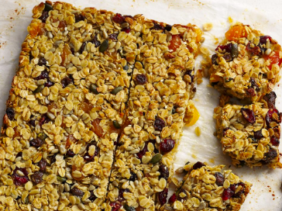

This version is slightly more healthy than normal, with a bit less butter and syrup, so it's great for families.

Ingredients
oil, for greasing
100g/3½oz butter, cubed
100g/3½oz golden syrup
50g/1¾oz mixed seeds, such as pumpkin, sunflower, linseed and sesame
50g/1¾oz dried cranberries
50g/1¾oz raisins
50g/1¾oz dried apricots, cut into sixths
250g/9oz jumbo porridge oats (gluten-free, if required)
1 large free-range egg, beaten

Instead of dried fruit you could add extra pumpkins seeds to take it to 200g

Method
Preheat the oven to 200C/180C Fan/Gas 6. Lightly oil a shallow 20cm/8in loose-based square cake tin and line the base and sides of the tin with baking parchment.

Melt the butter and syrup together in a large saucepan over a low heat, stirring regularly with a wooden spoon. Take off the heat and stir in the seeds, cranberries, raisins and apricots and oats. Stir in the egg.

Spoon into the prepared tin and press until well flattened. (It’s important that the oats are pressed well, so that they stay firm enough to cut when baked. Use the back of a metal spoon to make sure they are fully compressed). Bake for 18–20 minutes, or until golden and lightly browned around the edges.

Mark the flapjack into 12 pieces without cutting all the way through, this will make it easier to cut the flapjack when it's cool. Leave until cold then cut the flapjack with a sharp knife.

Store in an airtight container, interleaved with baking parchment or foil for up to three days.

